<EMPTY><EMPTY>

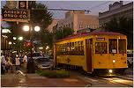

The Church at Argenta is located on the North Shore of Little Rock in Central Arkansas. Its Goal is simple. To reach people with the life changing message of Jesus Christ by meeting their physical, mental, emotional and spiritual needs while crossing social, ethnic and economical boundaries.

Argenta District at Night

Argenta’s Mission

**Believe. Belong. Become.**

We exist to encourage people to **believe** in Jesus as Lord of their lives and in the person God sees them as, while helping them **belong** to the church family as well as the community and encourage them to **become** the ministers God has called them to be in their world and beyond!

**The Church at Argenta**

…where Jesus changes everything…

[www.churchatargenta.org](http://www.churchatargenta.org)

(coming soon)

Believe.

Belong.

Become.



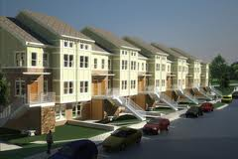

The Church at Argenta

…where Jesus changes everything…

…More facts about the area

-1 in 4 children go hungry.

-While the area seems to be vibrant, an undercurrent of poverty flows unnoticed.

-Homeless families have nowhere to stay together as a family unit.

-Literacy and high school graduation is low.

-After children leave foster care at the age of eighteen they are offered a four year college education paid for by the state. Only 13% take advantage of this with only 3% succeeding. Most end up in jail, low-income housing or on the streets with little education or job experience.

-Resources for unplanned pregnancy are slim.

-Counseling services for the low-income population are almost non-existent.

-While the needs of the community are huge, very few seem to be interested, including the church.

Facts about North Little Rock

-North Little Rock is located in Central Arkansas just across the river from Little Rock, Arkansas capitol.

-There are around 100,00 people living in North Little Rock, with another estimated 300,000 living in surrounding areas within a fifteen mile radius.

-There are hundreds of churches in the same area.

-Argenta is a community in the downtown urban area of North Little Rock.

-Argenta is a combination of poverty stricken neighborhoods, new urban neighborhoods, arts district and a restaurant/entertainment district.

-

Continue newsletter text here. Continue flyer text here. Continue flyer text here. Continue flyer text here. Continue flyer text here. Continue flyer text here. Continue flyer text here. Continue flyer text here. Continue flyer text here. Continue flyer text here. Continue flyer text here. Continue flyer text here. Continue flyer text here. Continue flyer text here. Continue flyer text here. Continue flyer text here. Continue flyer text here. Continue flyer text here. Continue flyer text here. Continue flyer text here. Continue flyer text here. Continue flyer text here. Continue flyer text here.

Continue flyer text here. Continue flyer text here. Continue flyer text here. Continue flyer text here. Continue flyer text here. Continue flyer text here. Continue flyer text here.

**SUB-HEAD**

Continue flyer text here. Continue flyer text here. Continue flyer text here. Continue flyer text here. Continue flyer text here. Continue flyer text here. Continue flyer text here. Continue flyer text here. Continue flyer text here. Continue flyer text here. Continue flyer text here. Continue flyer text here. Continue flyer text here. Continue flyer text here. Continue flyer text here. Continue flyer text here. Continue flyer text here. Continue flyer text here. Continue flyer text here. Continue flyer text here. Continue flyer text here. Continue flyer text here. Continue flyer text here. Continue flyer text here. Continue flyer text here. Continue flyer text here.

Continue flyer text here. Continue flyer text here. Continue flyer text here. Continue flyer text here. Continue flyer text here. Continue flyer text here. Continue flyer text here. Continue flyer text here. Continue flyer text here. Continue flyer text here. Continue flyer text here.

New development in Argenta District, Downtown North Little Rock

Neighborhood just blocks from Argenta District.

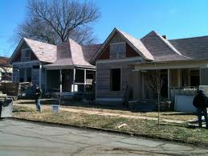

Believe. Belong. Become.

The Community of Argenta

te

…where Jesus changes everything…

The Church at Argenta



Argenta’s Ministries to the Community

**-Urban Market and Home Store –** At its core, The Urban market and Home Store is a glorified food pantry and thrift store. However, it is designed to function more as a grocery store. Eliminating the issue of pride and shame that some feel from seeking help from such organizations.

**-Counseling and Education Center-** This center is designed to offer free or low cost medical, dental and counseling services. As well as offer a place for people to earn their GED. We will also offer job skills, interview training, resume building and provide employers a place to seek workers and post job openings.

**-Life Choices-** By partnering with local OBGYN’s, Argenta will be able to provide free ultrasounds, pregnancy information, birthing classes, parent training and adoption information to those who find themselves in an unplanned pregnancy. The center will also provide a support group for ladies who have been through the process of abortion.

**-Transitional Living Program-** Realizing the need for a living space for homeless families and young adults (18-22) who are coming out of foster care, The Church at Argenta will build and provide duplexes to house four families and eight young adults. They will receive counseling and training while living on the premises. They will also receive help finding a job and a permanent housing situation. (Families will be allowed to stay for six months and young adults up to four years.)

**-The Portico-** The Portico is a private school designed for low income families to attend free of charge. With limited space, a lottery system will be put into place for those who qualify.

**-Other Plans-** Argenta will also be home to a café/bookstore, dorms for interns and summer missionaries, Welcome Center/Community Arts Center (Psalms of the Streets), Church, and Offices. All of these plans are designed to attract people to the community while accomplishing our mission to bring people to Christ and bridging the social, ethnic and economical gap. This community is waiting. We will answer the call because we believe Jesus changes everything!

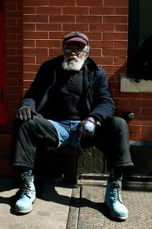



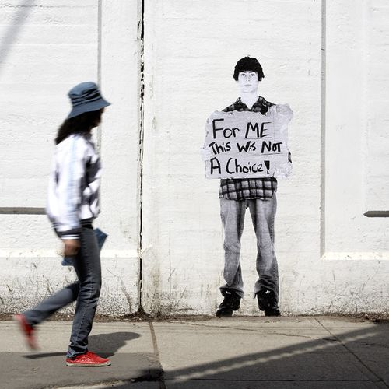



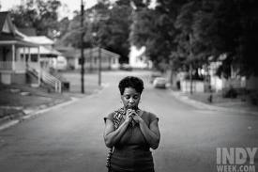

**Argenta’s 10 Core Values:**

1. We believe everyone matters to God and is valued by Him! Because of this ALL people are valued by the church and matter to the church! Grace will always be dispensed freely!

2. We believe a great commitment to the “Great Commission” and the “Great Commandment” will grow a great church!

3. We believe God has the power to change people and do things beyond our wildest imagination! Nothing is too difficult for Him!

4. We believe the message never changes but the methods always do!

5. We believe every member is a minister!

6. We believe people should minister according to their gifts!

7. We believe Prayer and Scripture are the most powerful weapons we posse in our ministry!

8. We believe worship is a lifestyle!

9. We believe our calling is first to God, then to our spouse/families and then to our church!

10. We believe to whom much is given, much is required!

Just a Thought…

If God has shown us grace through the death of His Son, if Jesus taught us to love our neighbor and not cast the first stone, if Paul taught us true ministry was helping widows and orphans, then why are we the last to offer grace, the first to past judgment and rarely think of the widows and orphans. Church is not a destination, it’s a lifestyle and it’s time we become the church Jesus started.

Believe. Belong. Become.

Delete text and

in image here

**SUBHEAD**

Continue newsletter text here. Continue newsletter text here. Continue newsletter text here. Continue newsletter text here. Continue newsletter text here. Continue newsletter text here. Continue newsletter text here. Continue newsletter text here. Continue newsletter text here. Continue newsletter text here. Continue newsletter text here. Continue newsletter text here. Continue newsletter text here. Continue newsletter text here.

Continue newsletter text here. Continue newsletter text here. Continue newsletter text here. Continue newsletter text here. Continue newsletter text here. Continue newsletter text here. Continue newsletter text here. Continue newsletter text here. Continue newsletter text here. Continue newsletter text here. Continue newsletter text here. Continue newsletter text here. Continue newsletter text here. Continue newsletter text here. Continue newsletter text here. Continue newsletter text here. Continue newsletter text here. Continue newsletter text here. Continue newsletter text here.

**SUBHEAD**

Continue newsletter text here. Continue newsletter text here. Continue newsletter text here. Continue newsletter text here. Continue newsletter text here. Continue newsletter text here. Continue newsletter text here. Continue newsletter text here. Continue newsletter text here. Continue newsletter text here. Continue newsletter text here. Continue newsletter text here. Continue newsletter text here.

Continue newsletter text here. Continue newsletter text here.

Continue newsletter text here. Continue newsletter text here. Continue newsletter text here. Continue newsletter text here.

*Delete box or insert a tag line or quote here.*

*Delete box or add photo caption here.*

*Volume: #1, Issue #1*

* **Use this area for bullet point call outs.**
* **Use this area for bullet point call outs.**
* **Use this area for bullet point call outs.**
* **Use this area for bullet point call outs.**
* **Use this area for bullet point call outs.**

NEWSLETTER HEADLINE HERE

Ways you can help!

* Prayer
* Come be a part of our team.
* Send us names and needs of people in the area.
* Come to our prayer meeting Tuesday nights at 6:30. Call 501-765-0881 for details.
* Consider helping us financially.
* Invite us to speak at your next luncheon, event or service. We would be thrilled to discuss what God is doing through The Church at Argenta.

**The Church at Argenta will official launch Easter Sunday morning, April 8th 2012!**

**Watch for more details to come!**

Argenta’s Dream

**It is the dream** of a place where the hurting, the depressed, the frustrated, and the confused can find love, acceptance, help, hope, forgiveness, guidance, grace and encouragement.

**It is the dream** of sharing the Good News of Jesus Christ with thousands of residents in Central Arkansas.

**It is the dream** of welcoming 20,000 members into the fellowship of our church family-fulfilling the great commission and the great commandment.

**It is the dream** of developing people to spiritual maturity through Bible studies, small groups, national training seminars, retreats, and Bible classes for our members.

**It is the dream** of equipping every believer for a significant ministry by helping them discover the gifts and talents God gave them.

**It is the dream** of sending out hundreds of career missionaries and church workers all around the world, while empowering every member for a personal life mission.

**It is the dream** of sending our members by the thousands on short-term mission projects to other inner cities on every continent.

**It is the dream** of starting at least one new daughter church every three years around the nation to continue what God has started at The Church at Argenta.

**It is the dream** of at least forty acres of land, on which to build a regional church for Central Arkansas-with beautiful, yet simple, facilities including a worship center seating thousands, an arts and community center, counseling and helping centers, a home for transitional youth and families, a pregnancy center for the low income , a private school for low income families, classrooms for Bible studies and training lay ministers, and a recreation area. All of this will be designed to minister to the local person-body, mind and soul with the intention of crossing racial, social and economic boundaries. The Church at Argenta will be set in a lush landscape on the river that will not only enhance the community but also draw other businesses to the area as well as revitalize an entire community.

These things have been in my heart for the last eleven years. Because of this, I confess these things today and state in confident assurance these dreams will become reality, not based on my vast knowledge or capability but rather based on the power of the God who called me.

-Nathan Winiecki Founder/Teaching Pastor

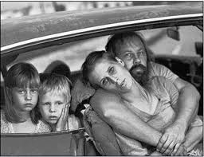

…where Jesus changes everything…

The Church at Argenta

Argenta’s future and how

you can help!

*Date: Month Day, Year*

*Volume: #1, Issue #1*